

**How to Sign into Microsoft Office 365/Outlook**

# 3. Log into Microsoft Office 365/Outlook

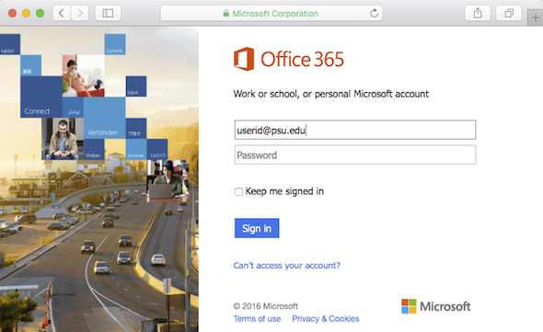

**Select Sign In** = student ID@yonkerspublicschools.org

**Your Password** = is the same one you use to login into a school computer.

**Stayed Sign In** = Check the box and select yes.

**Select Sign In** = student ID@yonkerspublicschools.org

**Your Password** = is the same one you use to login into a school computer.

1. **Go to: clever.com/in/yonkers** from any internet-enabled device and click **Office 365** or click on the **Office 365/Outlook Icon** on your School’s Website.
2. On a school laptop click the Office 365 Portal Icon.